**Science Reviewer**

**Transposing**

**Transposing:**

* **Transposing** – Is the **algebraic process of isolating a variable** by **systematically moving terms** from one side of the equation to the other **using inverse operations**, while maintaining **mathematical balance**.
* The goal is to rewrite the equation so that a specific variable becomes the **subject** — appearing **alone on one side** of the equation, usually the left.
* **Example**:

**Principle in Transposing:**

* An equation represents **equality between two expressions**. Any operation performed on one side **must** be performed on the other **to maintain balance**.
* When transposing, instead of explicitly doing the same operation to both sides, you use a **shorthand method**: you **move a term across the equal sign** and apply the **inverse of the operation**.
* **Inverse Operation –** When you **move a term across the equal sign**, you must **change its sign**.
* **Positive**, it becomes **negative** when moved. This keeps the **equation balanced**, just like a **see-saw**: whatever you do on one side, you must do on the other.
* **Negative**, it becomes **positive**.
* **Multiplied**, it becomes **divided**.
* **Divided**, it becomes **multiplied**.
* When transposing anything, the **order of operations** should be **inverted**.

**Rules and Techniques of Transposing:**

* **Only Move Complete Terms** – A term includes its **sign**, **coefficient**, and **variables.** You cannot move part of a term — move the **whole logical unit**.
* **Change the Operation When Moving Across**:
* If something is **added**, it becomes **subtracted**.
* If something is **multiplied**, it becomes **divided**.
* If something is **raised** to a **power**, apply the **root** to cancel it.
* If something is **inside** a **function** (like **log or sin**), apply the **inverse function**.
* **Work from the Outermost Layer Inward**:
* Start by removing **external constants**.
* Then eliminate **operations wrapped around the variable**.
* Finish by **isolating the variable** in its pure form.
* **Watch Out for Grouping and Distribution** – Terms in **parentheses**, **brackets**, or **under radicals** must be either **expanded** (distributed) or **kept together** and isolated entirely.
* **Maintain Symmetry** – The equality (=) is **sacred**. Every transposition must **preserve** it. You're not "moving" things like rearranging furniture — you're applying **legal inverse operations** that keep the equation balanced.

**Critical Considerations:**

* **Signs are attached** to the term. Always bring the sign with the number when transposing.
* **Fractions and division** must be handled as **entire expressions**. Never split numerators and denominators without distributing.
* **Nested operations** (like an exponent inside a parenthesis) must be dealt with by **reverse layering**, respecting **SEDMAP**.
* **Function inverses** (e.g., from log to 10^, sin to arcsin) are forms of transposition used in higher mathematics.

**How to Decide What to Transpose:**

* To decide what to transpose, you must first ask yourself: And follow SEDMAP, and unravel layer by layer until the variable stands alone.
* **What is my target variable?**
* **What operations surround or obstruct it?**
* **What is the outermost operation touching it?**
* **Which inverse undoes that operation?**

**Simplified Explanation:**

* **Every transposition is an inverse operation**.
* **SEDMAP guides the process of isolation**, in reverse of how the expression was built.
* **Parentheses, fractions, and functions** require special attention — they group operations and must be **respected or undone** methodically.
* **Do not simplify until after transposing**, unless simplification clarifies structure.

**Electricity and Magnetism**

**Electrical Nature of Matter:**

* **Proton** () – Are **positively charged particles** of an atom
* **Neutrons** –Are particles of an atom that has **no charge**.
* It is neutral
* **Electrons** () – Are **negatively charged particles** and are much lighter than the protons
* **Electrified** – A **body which has excess positive charge or excess negative charge**.
* **Electrification** - The process of charging.
* **Electrostatics** – Is the **branch of physics that studies electric charges at rest** and the forces and fields they produce.
* **Electroscope** – Is a **device used to detect the presence and type** (positive or negative) of electric charge on an object through the movement of metal leaves or needle.
* **Conductors** – Materials, like metals, in **which electrons can move freely**, allowing electric current or static charges to flow easily.
* **Insulators (Non-conductors)** – Materials, such as rubber or plastic, **where electrons are tightly bound and cannot move freely**, preventing the flow of electric charge.

**Static Electricity:**

* **Electrostatics** – Is the **branch of physics that studies electric charges at rest** and the forces and fields they produce.
* **Electric Field (Electrostatic Field)** – The **region surrounding a charged body**. But for purpose of making the concept understood, the electric fields may be represented graphically by **lines of force**.
* Suppose two **unlike but equal charges** are placed near each other. The two **electric fields combin**e to form a **single resultant field**. The **lines of force originate** from the **positive charge and terminate at the negative** charge.
* If **two charges are equal and both positive**; the **tangent to a line of force at a point gives the direction of the force that would act on a positive** charge if placed at the point.
* The lines of force never intersect whether the charges are different or the same. There is a force of attraction between two unlike charges. There is repulsion between two like charges.

**Coulomb’s Law:**

* **Charles Coulomb** – **Found the relation between the force of attraction or repulsion** between two charged bodies and the magnitude of these charges.
* **Force of Attraction or Repulsion** – Between **two small charged bodies is directly proportional to the product of the two charges** and **inversely proportional to the square of the distance** between these charges.

|  |  |  |
| --- | --- | --- |
| **Formula:** | **Definition:**  **F** = electrostatic force between two charges (in newtons, N)  **k** = Coulomb's constant (**8.99 × 10⁹ N·m²/C²**)  **q₁** = magnitude of the first charge (in coulombs, C)  **q₂** = magnitude of the second charge (in coulombs, C)  **d** = distance between the centers of the two charges (in meters, m) | |
| **Example:** | | **Given Problem:**  Two small metal spheres are charged and placed on an insulated table **0.5 meters apart**. One sphere carries a charge of **2 × 10⁻⁶ coulombs**, and the other carries a charge of **3 × 10⁻⁶ coulombs**. **Calculate the magnitude of the electrostatic force** acting between them. |
| **Formula Full Name:** | | |

* In the MKS system of units, **the unit of charge is the coulomb**, the force is expressed in newtons and distance in meters. A coulomb is a very large unit of charge. A smaller unit is the statcoulomb.
* **Statcoulomb** – The **electrostatic unit of charge**, is the amount of charge which, when placed at a distance of 1cm from a similar charge in a vacuum, repels it with a force of 1 dyne.

**Electric Charge:**

* **Electric Charge** – Exists if there is an excess or deficiency in the number of electrons. The amount of electric charge contained in a body is given by the equation:

|  |  |  |
| --- | --- | --- |
| **Formula:** | **Definition:**  **q** = total electric charge (in **Coulombs, C**)  **n** = number of excess or deficient electrons or protons (unitless, just a count)  **e** = elementary charge of an electron (**1.6 × 10⁻¹⁹ C**) | |
| **Example:** | | **Given Problem:**  How much charge is carried by **3.5 × 10¹⁹ electrons**?  (Always remember electrons will always be negative) |
| **Formula Full Name:** | | |

**Electric Potential:**

* **Electric Potential** – The potential energy possessed by a unit charge is called the **electric potential** or electrostatic potential. At that point. The unit of electric potential in the MKS system is the **volt**.
* The difference in electric potential is equal to the work required to bring a unit positive charge from P2 to P1

|  |  |  |
| --- | --- | --- |
| **Formula:** | **Definition:**  **Wk** = work done or electric potential energy (in joules, J)  **q** = electric charge (in coulombs, C)  **V** = electric potential (or voltage) difference (in volts, V) | |
| **Example:** | | **Given Problem:**  How much work is done in moving a **3 C** charge through a potential difference of **12 V**? |
| **Full Formula:** | | |

* **Voltage** – Is a measure of the electrical potential difference, representing the energy available to drive the flow of charges through the circuit. The volt is named after **Alessandro Volta**, who conducted research on early batteries.

|  |  |  |
| --- | --- | --- |
| **Formula:** | **Definition:**  **V** = **electric potential** or **voltage** (in **volts, V**)  **W** = **work done** or **electric potential energy** (in **joules, J**)  **q** = **electric charge** (in **coulombs, C**) | |
| **Example:** | | **Given Problem:**  If **45 joules** of work is done to move a charge of **15 C**, what is the electric potential? If **45 joules** of work is done to move a charge of **15 C**, what is the electric potential? |
| **Full Formula:** | | |

* Just as heat flows through a heat conductor until there is no longer a temperature difference, charge wants to flow through an electrical conductor until there is no more potential difference.

**Current Electricity and Ohm’s Law:**

* **Electric Current** – Electric current is the **motion at which electric charge flows through a conductor**. Defined as the amount of net charge q passing through a unit cross section of area per unit time.

|  |  |
| --- | --- |
| **Formula:** | **Formula Definition:** |
| **Example:** | **Given Problem:** |
| * In the MKS system, the unit of current is **ampere,** from Andre Marie Ampere. The smaller units of current are the milliampere and the microampere. * 1 ampere = 1000 milliamperes or 10 microamperes | |

* The electrons which carry negative charge is attracted to the end of the conductor attached to the positive terminal of the battery. A difference in potential is set up which enables the electrons to move. An electric current is said to be set up within the wire. If the difference in potential is maintained, there will be a continuous flow of electrons.
* A flow of electrons in one direction is equivalent to the flow of positive charges in the opposite direction. By convention, the direction of flow of positive charges is considered the direction of electric current. Thus, whenever the direction of current is mentioned, it is the conventional current which is referred to, and not the electron current.
* **Direct Current (DC)** – The electron flow is in one direction only, which is from the negative to the positive terminal of the source.
* **Alternating Current (AC)** – Where current is produced by constantly changing voltage from positive to negative positive and so on.

**Current Electricity and Ohm’s Law:**

* The voltage supplied to the external circuit is known as the terminal voltage; that is

|  |  |  |
| --- | --- | --- |
| **Formula:** | **Formula:** | **Formula:** |
|  |  |  |
|  |  |  |

* An example of the first type of source is what is known as a **primary cell**. A typical primary cell is the common flashlight cell, which is also called a *dry cell and the voltaic cell*.
* A source has an EMF of 1 volt if it does 1 joule of work to transfer 1 coulomb of charge from the negative electrode to the positive electrode.

**Current Electricity and Ohm’s Law:**

* In cases of the storage cell, the chemical energy which has been used up is replaced by a process known as recharging. The second type of source of EMF is exemplified by the generator. Here the mechanical energy is converted to electrical energy.
* The instrument used to measure electric current is ampere is called ammeter. A similar instrument with calibrations in milliamperes is a milli-ammeter. The instrument used to measure EMF in volts is a voltmeter.

**Resistance and Ohm’s Law:**

* It is learned that electrons can readily flow in metallic conductors. However, these conductors offer some resistance to the flow of electrons. Such resistance varies in different materials.
* **Resistance** – A property of a conductor which is affected by the length, cross-sectional area and temperature of the conductor and the nature of the material the conductor is made of.
* Generally, the resistance of metallic conductors increases with an increase in temperature. Carbon is an exception to this.
* Other things being equal, the resistance of conductors is directly proportional to length and inversely proportional to the area of the cross section

|  |  |
| --- | --- |
| **Formula:** |  |
|  |  |

* If A is a unit area and L is a unit length, then p is numerically equal to R. This quantity *p* denotes the resistivity of a material.
* The **resistivity** of a conductor is the resistance offered by that conductor of unit length and unit cross section to the passage of a current flowing in the direction perpendicular to the cross section.
* The unit of resistance is **ohm**, denoted by the Greek letter omega Ω. This attributed to Georg Simon Ohm. Thus, the unit for resistivity is **ohm-meter**.

**Electric Circuits:**

* **Electric Circuits** – An electric circuit is a closed loop or path that allows electric current to flow. An electric circuit includes a device that gives energy to the charged particles constituting the current; devices that use current and the connecting wires or transmission lines.

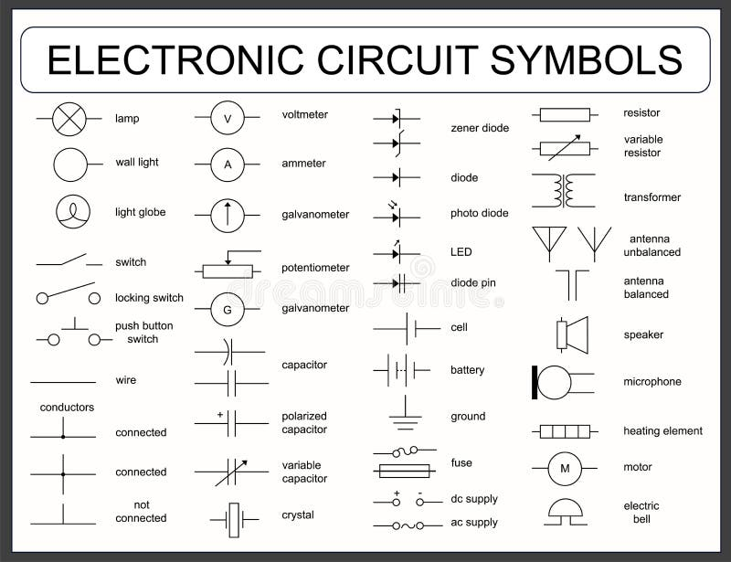

* Ohm’s law holds for the whole circuit or for any portion of the circuit provided the portion does not include a source of EMF. If Ohm’s law is to be applied to the whole circuit, V is the net EMF of the sources in the circuit and R is the sum of the internal and external resistances of the circuit. The internal resistance is the resistance of the source of EMF.
* This shows that TPD is less than the EMF of the cell by an amount which is equal to the voltage drop due to R in the cell. If R is constant, then the voltage drop is proportional to the current.
* The greater the current in the circuit, the less is the TPD of the cell.

**Series vs Parallel Circuits:**

* Resistances are said to be in **series** when there is only one path for the current such that the current passing through any one of them is the same current passing through the other resistances in the combination.
* Resistance is said to be in **parallel** when the total current divided among the different resistances in the combination.
* A **combination of series and parallel** contains load elements placed both in series and parallel, which have the effects of both lowering the voltage and dividing the current. The effective resistance of this combination will be three halves that of a single resistive element.

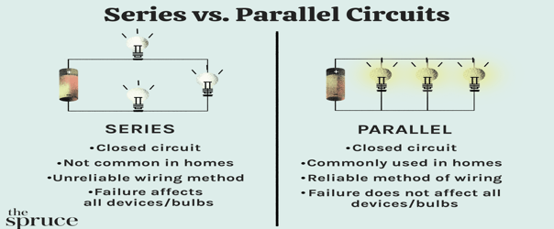

|  |  |
| --- | --- |
| **Resistances In Series:** | **Resistances In Parallel:** |

**Electric Circuits:**

* The reciprocal of the resistance, 1/R, is called **conductance**. Its unit is mho.
* Cells are said to be **in series** if the positive terminal of one cell is connected to the negative terminal of the next cell, and so on.
* Cells are said to be **in parallel** when all the positive terminals are connected to each other and all the negative terminals are connected to each other.

|  |  |
| --- | --- |
|  |  |